Post-Lab 2: BLE

## What to submit?

Please use this document as a template, add your responses directly, and export it as a PDF to Gradescope. Each group should submit one post-lab.

**Name: Rajan Verma**

**Student ID:A69028626**

**Link to GitHub repository:**

# F: Investigating BLE Advertisements

1. **How many transmissions do you see in one second?**

**Looks like 800 packets   
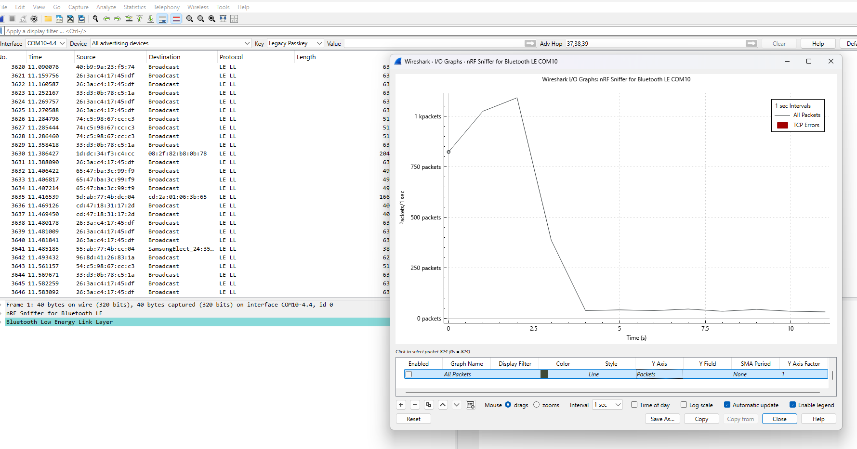**

1. **Pick a received advertisement, show me the packet data, and explain the meaning of all of the bytes of it.**

# 

# *0a - First byte (Header)*

# *38 - Length (56 bytes)*

# *00 - Reserved/Flags*

# *03 - PDU Type (SCAN_REQ)*

# *01 87 - Event counter*

# *02 - Timestamp BLE Packet Header 0a - Header byte*

# *00 - Additional header info*

# *25 53 - Access address part*

# *00 00 - Reserved*

# *BLE Packet Body :*

# *d6 be 89 8e - Standard advertising access address*

# *42 25 b4 fd f5 4c 5a 07 - Device address Advertisig data : 1e - Length*

# *ff - Manufacturer Specific Data type*

# *06 - Company ID (part 1)*

# *00 - Company ID (part 2)*

# *01 6f 29 57 4c f3... - Manufacturer specific payload data*

# *CRC : df 4e 4c - CRC (Cyclic Redundancy Check)*

# H: Programming a BLE Advertiser

1. **Show evidence you were able to create an advertiser with your custom name:  
     
   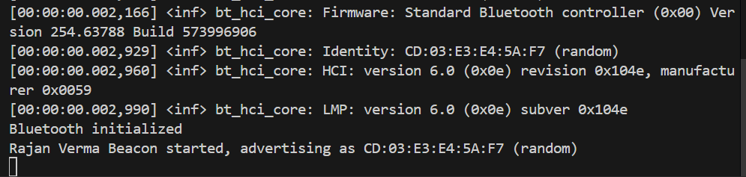**

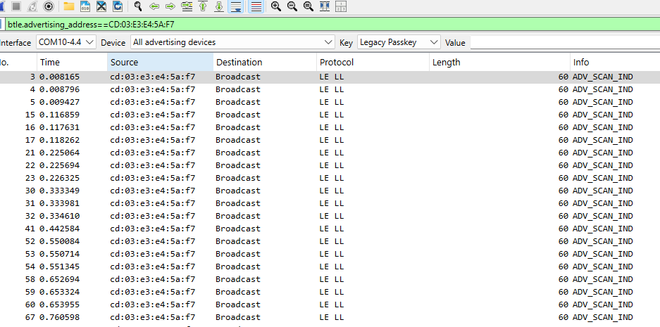

1. **Link to your updated code:**

https://github.com/rverma999/MAS_WES_269/tree/main/Lab2

# I: Programming a BLE Scanner

1. **Show evidence you were able to implement a scanner with the nRF52840DK:**
2. **Show evidence your device asked for a scan response**
3. **Show evidence another device another device sent a scan response:**
4. **Link to your updated code:**

# J: BLE Peripheral

1. **What is the initial value of the characteristic in the provided code?**
2. **Link to your updated code:**

# K: BLE Central

1. **Show the terminal output showing the count increasing:**
2. **Link to your updated code:**

# L: LED Controller Application

1. **Write a few sentences on what you had to do to make this work. Particularly note anything that was especially challenging to get working.**
2. **Link to your new code:**
3. **CHECKOFF: Showcase the central board controlling the LEDs of the peripheral board to a TA during lab or office hours**